Assignment 1 : Simple SQL Query with a single table with where clause.
Northwind database
Sample table: Products
-ProductID
-ProductName
-SupplierID
-CategoryID
- QuantityPerUnit
-UnitPrice
-UnitsInStock
-UnitsOnOrder
-ReorderLevel
-Discontinued

1. Write a query to get a Product list (id, name, unit price) where current products cost less than $20.
ANS:
SELECT product_id,product_name,unit_price FROM Products WHERE unit_price<20;

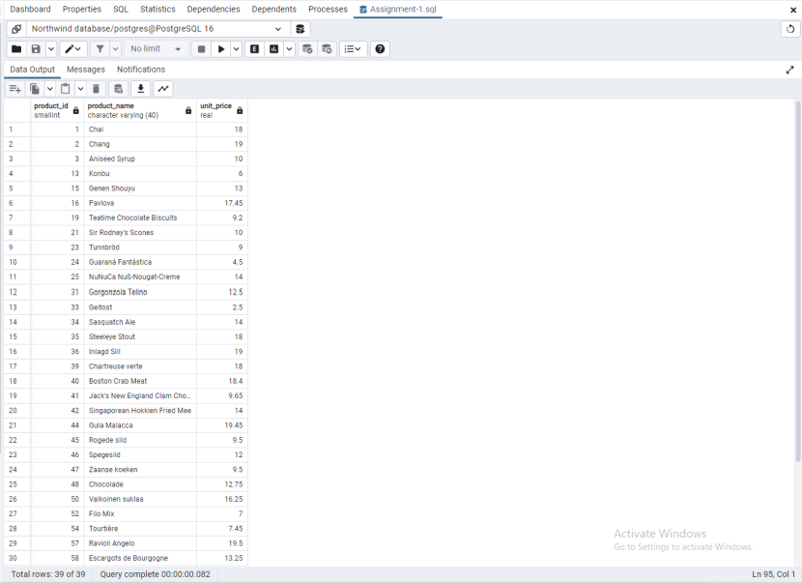

2. Write a query to get Product list (id, name, unit price) where products cost between $15 and $25.
a. Write a query to get Product list (name, unit price) of above average price.
b. Write a query to get Product list (name, unit price) of ten most expensive
products.

ANS:
SELECT product_id,product_name,unit_price FROM Products WHERE unit_price BETWEEN 15 AND 25;
SELECT product_name,unit_price FROM Products WHERE unit_price>(SELECT AVG(unit_price) FROM Products);
SELECT product_name,unit_price FROM Products ORDER BY unit_price DESC LIMIT 10;

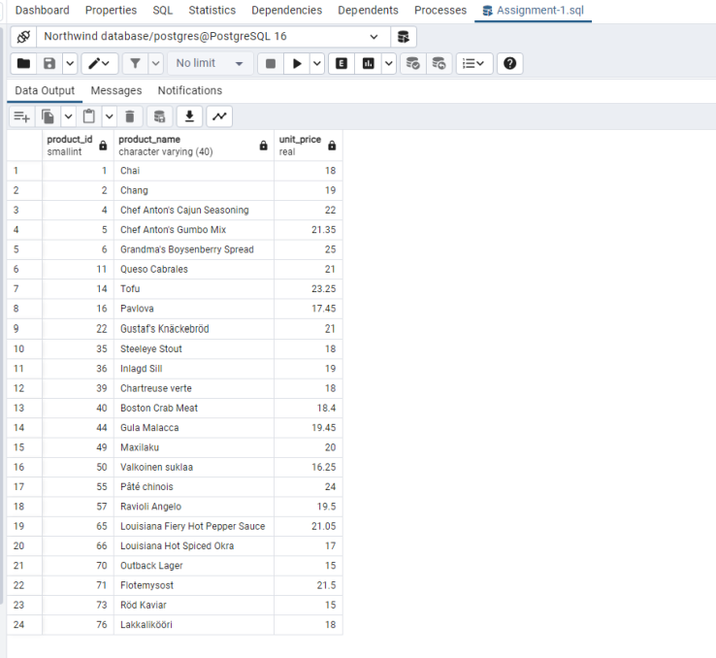

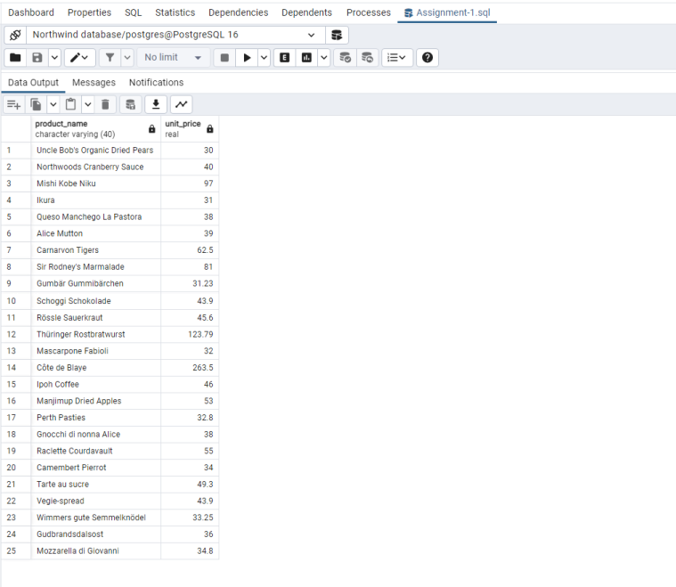

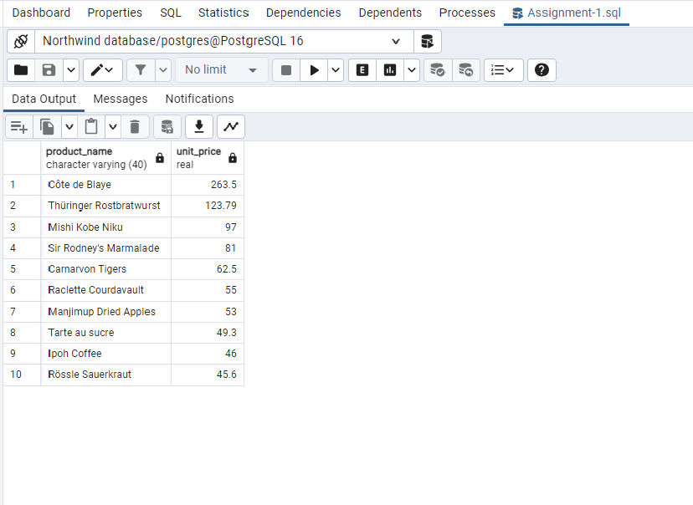

3. Write a query to count current and discontinued products.

ANS:
SELECT COUNT(discontinued) from Products WHERE discontinued='0' Union SELECT COUNT(discontinued) from Products WHERE discontinued='1';
OR
SELECT SUM(discontinued) AS DISCONTINUED, (COUNT(*) - SUM(discontinued)) AS CONTINUED FROM Products;

4. Write a query to get Product list (name, units on order, units in stock) of stock is less than the quantity on order.

ANS:
SELECT product_name,units_on_order,units_in_stock From Products WHERE units_in_stock<units_on_order;

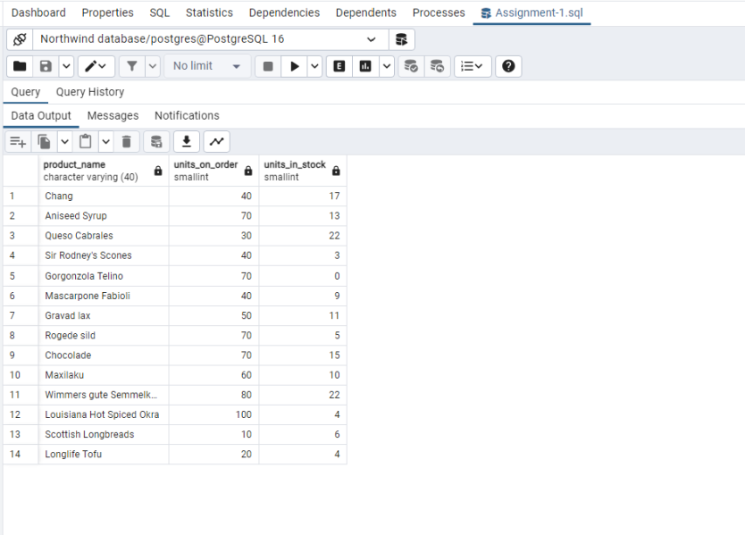

Assignment 2 : Retrieve data using join with where clause.

Sample table1: salesman
-salesman_id
-name
-city
-commission
Sample table2: customer
-customer_id
-cust_name
-city
-grade
-salesman_id
Sample table3: orders
-ord_no
-purch_amt
-ord_date
-customer_id
-salesman_id

SALESMAN TABLE:
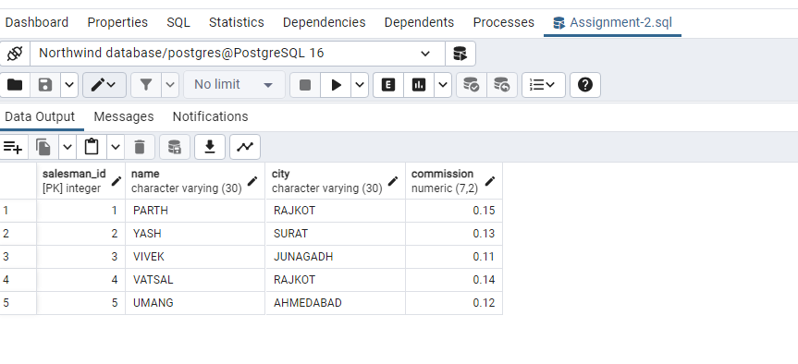
CUSTOMER TABLE:
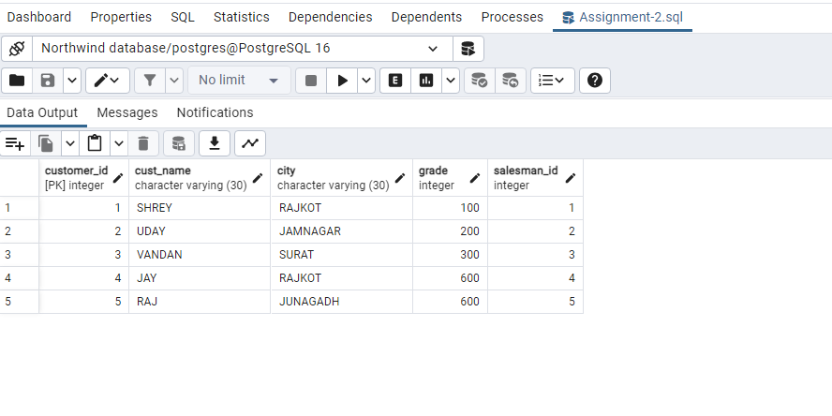

ORDERS TABLE:
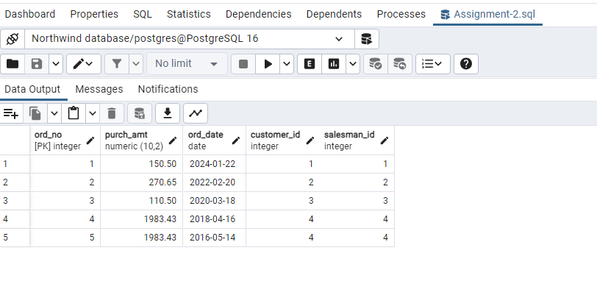

1. Write a SQL query to find the salesperson and customer who reside in the same city.
Return Salesman, cust_name and city.
ANS:
SELECT name,cust_name,salesman.city FROM SALESMAN INNER JOIN CUSTOMER ON SALESMAN.city=CUSTOMER.city;

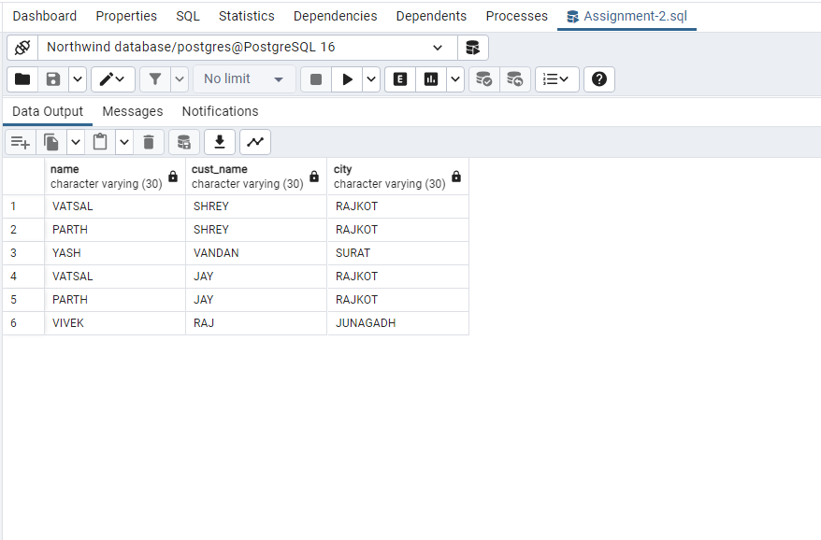
2. Write a SQL query to find those orders where the order amount exists between 500 and 2000. Return ord_no, purch_amt, cust_name, city .
ANS:
SELECT ord_no,purch_amt,cust_name,CUSTOMER.city FROM ORDERS INNER JOIN CUSTOMER ON ORDERS.ord_no = CUSTOMER.customer_id
where ORDERS.purch_amt BETWEEN 500 AND 2000;
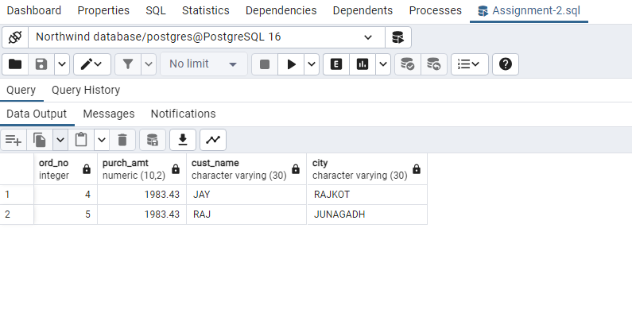
3. Write a SQL query to find the salesperson(s) and the customer(s) he represents. Return Customer Name, city, Salesman, commission.
ANS:
SELECT cust_name,CUSTOMER.city,name,commission FROM CUSTOMER INNER JOIN SALESMAN ON CUSTOMER.customer_id=SALESMAN.salesman_id;

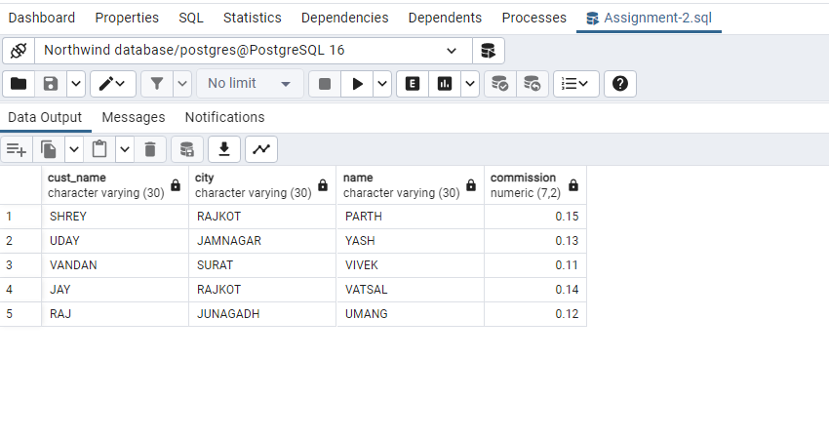
4. Write a SQL query to find salespeople who received commissions of more than 12 percent from the company. Return Customer Name, customer city, Salesman, commission.

ANS:
SELECT cust_name,CUSTOMER.city,name,commission FROM CUSTOMER INNER JOIN SALESMAN ON CUSTOMER.customer_id=SALESMAN.salesman_id WHERE commission>0.12;

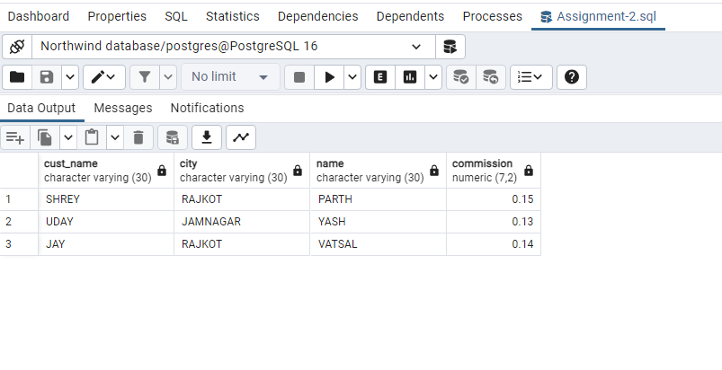

5. Write a SQL query to locate those salespeople who do not live in the same city where their customers live and have received a commission of more than 12% from the company. Return Customer Name, customer city, Salesman, salesman city, commission.
ANS:
SELECT cust_name,CUSTOMER.city,name,SALESMAN.city,commission FROM CUSTOMER INNER JOIN SALESMAN ON CUSTOMER.customer_id=SALESMAN.salesman_id WHERE CUSTOMER.city<>SALESMAN.city AND commission>0.12;

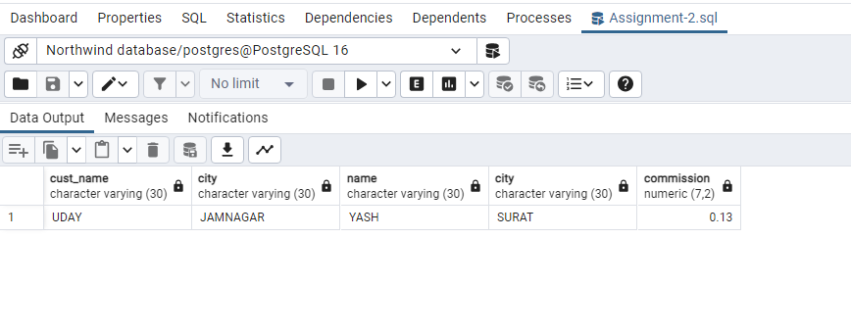
6. Write a SQL query to find the details of an order. Return ord_no, ord_date, purch_amt, Customer Name, grade, Salesman, commission.
ANS:
SELECT ord_no,ord_date,purch_amt,cust_name,grade,name,commission FROM ORDERS INNER JOIN CUSTOMER ON ORDERS.ord_no=CUSTOMER.customer_id INNER JOIN SALESMAN ON ORDERS.ord_no=SALESMAN.salesman_id;

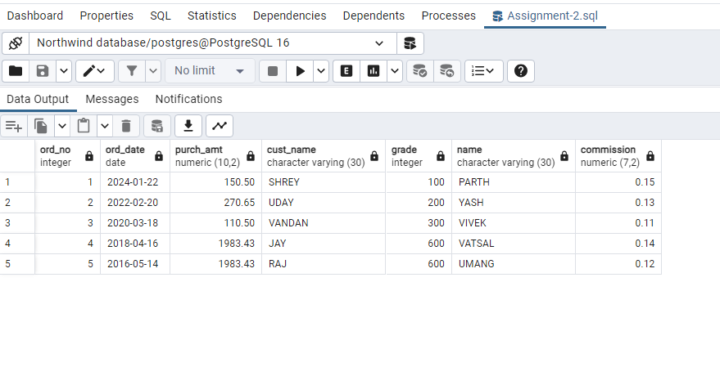

7. Write a SQL statement to join the tables salesman, customer and orders so that the same column of each table appears once and only the relational rows are returned.
ANS:
SELECT * FROM ORDERS NATURAL JOIN CUSTOMER NATURAL JOIN SALESMAN;

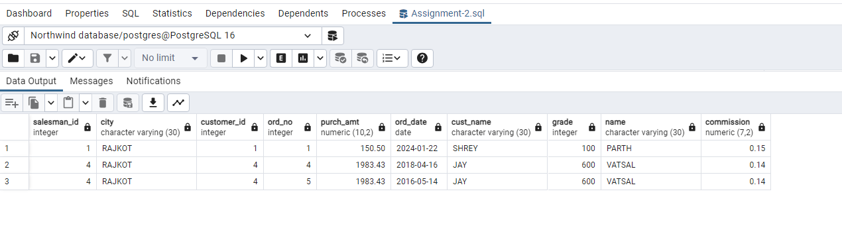
8. Write a SQL query to display the customer name, customer city, grade, salesman, salesman city. The results should be sorted by ascending customer_id.
ANS:
SELECT cust_name,CUSTOMER.city,grade,name,SALESMAN.city FROM CUSTOMER LEFT JOIN SALESMAN ON CUSTOMER.customer_id=SALESMAN.salesman_id ORDER BY CUSTOMER.customer_id;
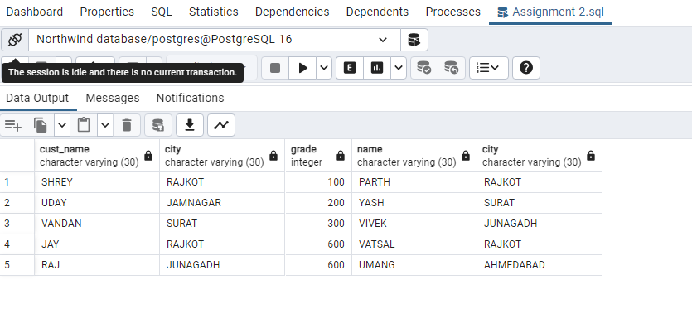

9. Write a SQL query to find those customers with a grade less than 300. Return cust_name, customer city, grade, Salesman, salesmancity. The result should be ordered by ascending customer_id.
ANS:
SELECT cust_name,CUSTOMER.city,grade,name,SALESMAN.city FROM CUSTOMER LEFT OUTER JOIN SALESMAN ON CUSTOMER.customer_id=SALESMAN.salesman_id WHERE CUSTOMER.grade<300 ORDER BY CUSTOMER.customer_id;
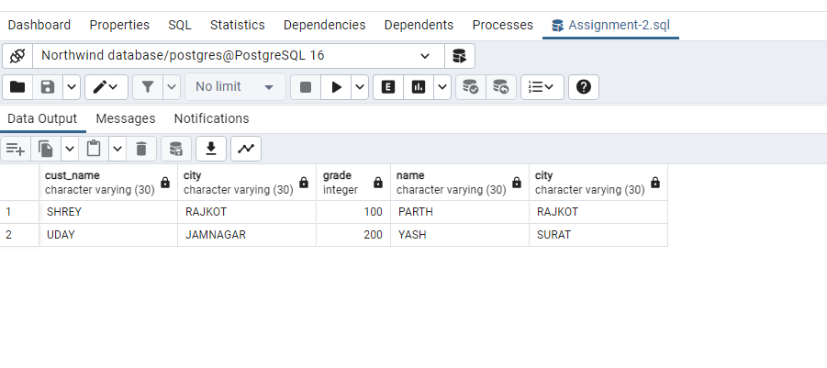
10. Write a SQL statement to make a report with customer name, city, order number, order date, and order amount in ascending order according to the order date to determine whether any of the existing customers have placed an order or not.
ANS:
SELECT cust_name,CUSTOMER.city,ord_no,ord_date,purch_amt FROM CUSTOMER LEFT OUTER JOIN ORDERS ON CUSTOMER.customer_id=ORDERS.ord_no ORDER BY ORDERS.ord_date;

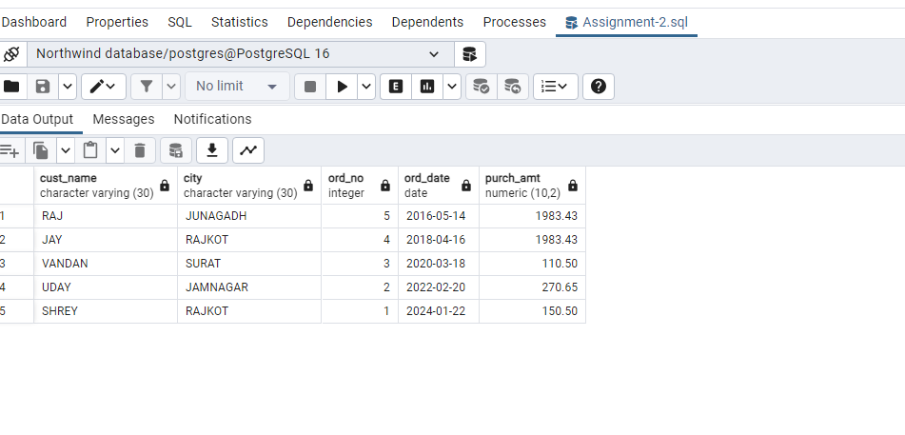

11. Write a SQL statement to generate a report with customer name, city, order number, order date, order amount, salesperson name, and commission to determine if any of the existing customers have not placed orders or if they have placed orders through their salesman or by themselves.
ANS:
SELECT cust_name,CUSTOMER.city,ord_no,ord_date,purch_amt,name,commission FROM CUSTOMER LEFT OUTER JOIN ORDERS ON CUSTOMER.customer_id=ORDERS.ord_no LEFT OUTER JOIN SALESMAN ON SALESMAN.salesman_id=ORDERS.ord_no;
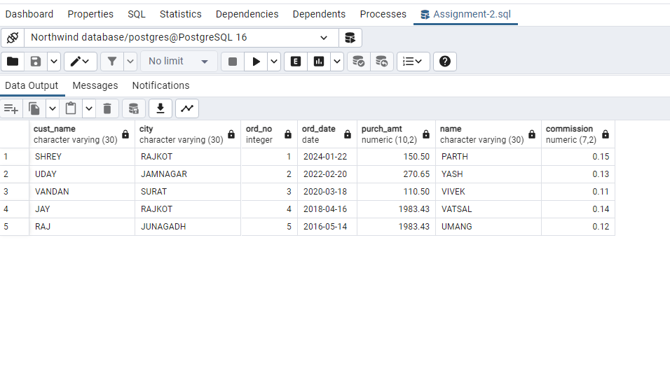
12. Write a SQL statement to generate a list in ascending order of salespersons who work either for one or more customers or have not yet joined any of the customers.
ANS:
SELECT CUSTOMER.cust_name,CUSTOMER.city,grade,name,SALESMAN.salesman_id FROM CUSTOMER RIGHT OUTER JOIN SALESMAN ON CUSTOMER.customer_id=SALESMAN.salesman_id ORDER BY SALESMAN;
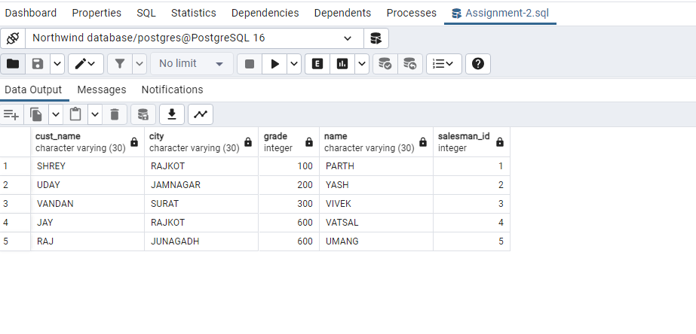
13. write a SQL query to list all salespersons along with customer name, city, grade, order number, date, and amount.
ANS:
SELECT name,cust_name,CUSTOMER.city,grade,ord_no,ord_date,purch_amt FROM CUSTOMER INNER JOIN SALESMAN ON CUSTOMER.customer_id=SALESMAN.salesman_id INNER JOIN ORDERS ON CUSTOMER.customer_id=ORDERS.ord_no;
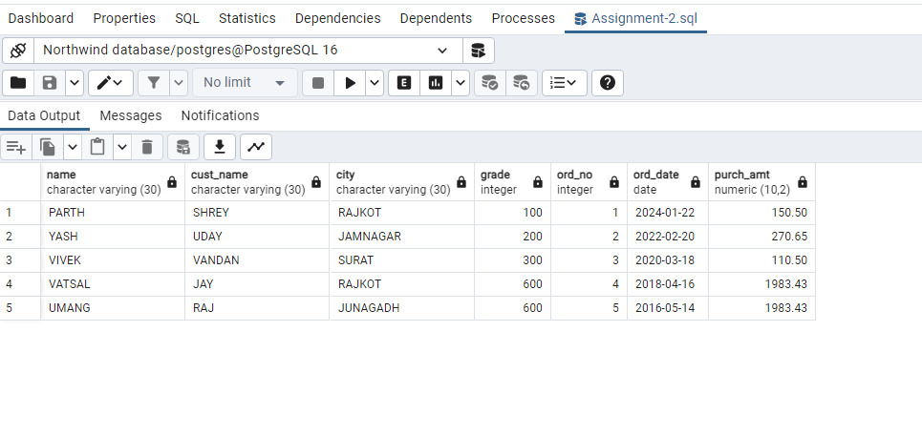
14. Write a SQL statement to make a list for the salesmen who either work for one or more customers or yet to join any of the customers. The customer may have placed, either one or more orders on or above order amount 2000 and must have a grade, or he may not have placed any order to the associated supplier.
ANS:
SELECT cust_name,CUSTOMER.city,grade,name,ord_no,ord_date,purch_amt FROM CUSTOMER RIGHT OUTER JOIN SALESMAN ON CUSTOMER.customer_id=SALESMAN.salesman_id LEFT OUTER JOIN ORDERS ON CUSTOMER.customer_id=ORDERS.ord_no WHERE ORDERS.purch_amt>=200 AND CUSTOMER.grade IS NOT NULL;
OR

SELECT name,purch_amt,grade FROM SALESMAN JOIN CUSTOMER ON SALESMAN.salesman_id=CUSTOMER.customer_id JOIN ORDERS ON ORDERS.ord_no=CUSTOMER.customer_id WHERE ORDERS.purch_amt>=200 AND CUSTOMER.grade IS NOT NULL;

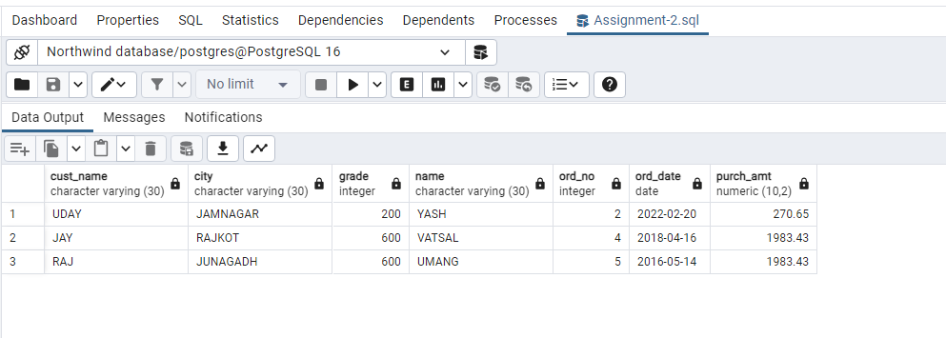

15. Write a SQL statement to generate a list of all the salesmen who either work for one or more customers or have yet to join any of them. The customer may have placed one or more orders at or above order amount 2000, and must have a grade, or he may not have placed any orders to the associated supplier.
ANS:
SELECT name,purch_amt,grade FROM SALESMAN JOIN CUSTOMER ON SALESMAN.salesman_id=CUSTOMER.customer_id JOIN ORDERS ON ORDERS.ord_no=CUSTOMER.customer_id WHERE ORDERS.purch_amt>=200 AND CUSTOMER.grade IS NOT NULL;
16. Write a SQL statement to generate a report with the customer name, city, order no. order date, purchase amount for only those customers on the list who must have a grade and placed one or more orders or which order(s) have been placed by the customer who neither is on the list nor has a grade.
ANS:
SELECT cust_name,CUSTOMER.city,ord_no,ord_date,purch_amt FROM CUSTOMER FULL OUTER JOIN ORDERS ON CUSTOMER.customer_id=ORDERS.ord_no WHERE grade IS NOT NULL;
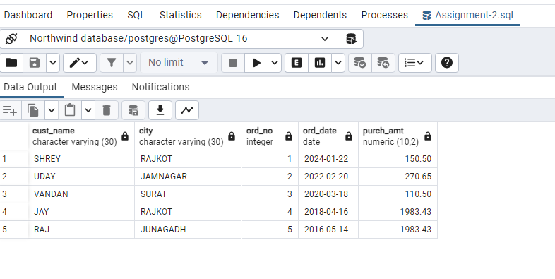

17. Write a SQL query to combine each row of the salesman table with each row of the customer table.
ANS:
SELECT * FROM SALESMAN CROSS JOIN CUSTOMER;
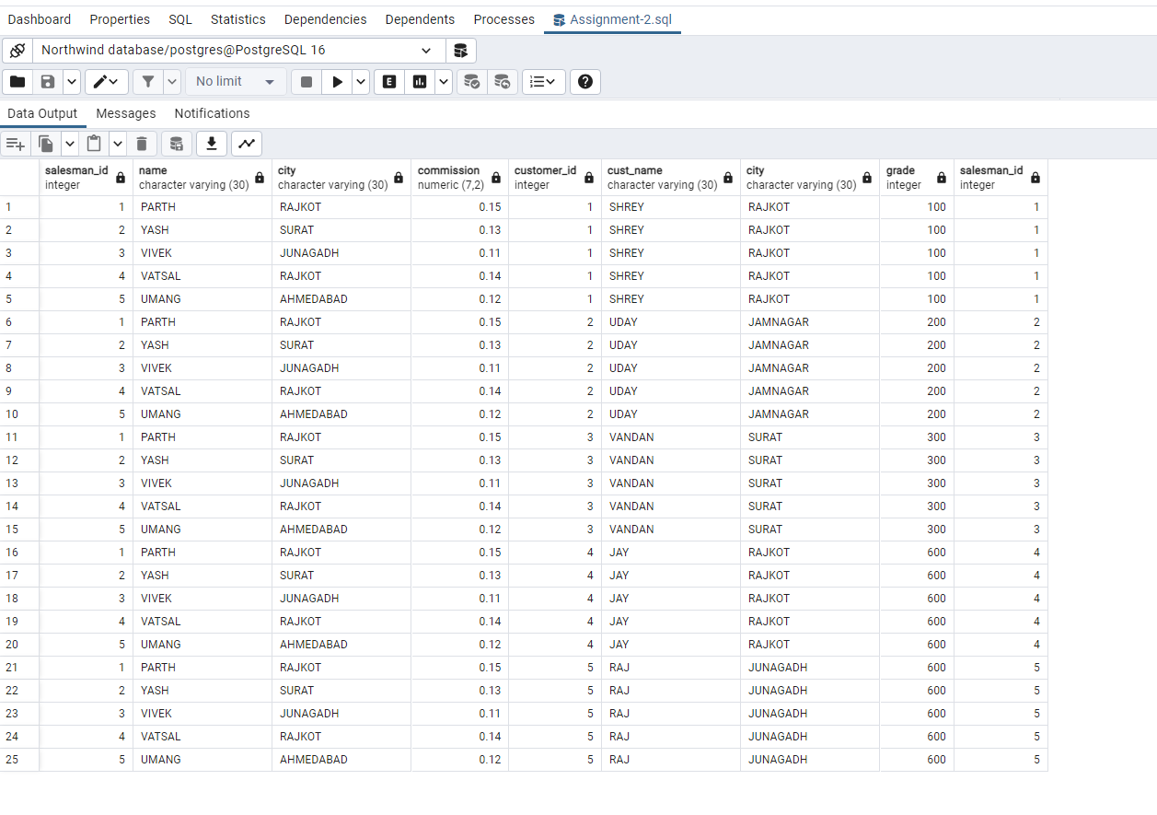
18. Write a SQL statement to create a Cartesian product between salesperson and customer, i.e. each salesperson will appear for all customers and vice versa for that salesperson who belongs to that city.
ANS:
SELECT * FROM SALESMAN CROSS JOIN CUSTOMER WHERE SALESMAN.city IS NOT NULL;
19. Write a SQL statement to create a Cartesian product between salesperson and customer, i.e. each salesperson will appear for every customer and vice versa for those salesmen who belong to a city and customers who require a grade.
ANS:
SELECT * FROM SALESMAN CROSS JOIN CUSTOMER WHERE SALESMAN.city IS NOT NULL AND grade IS NOT NULL;
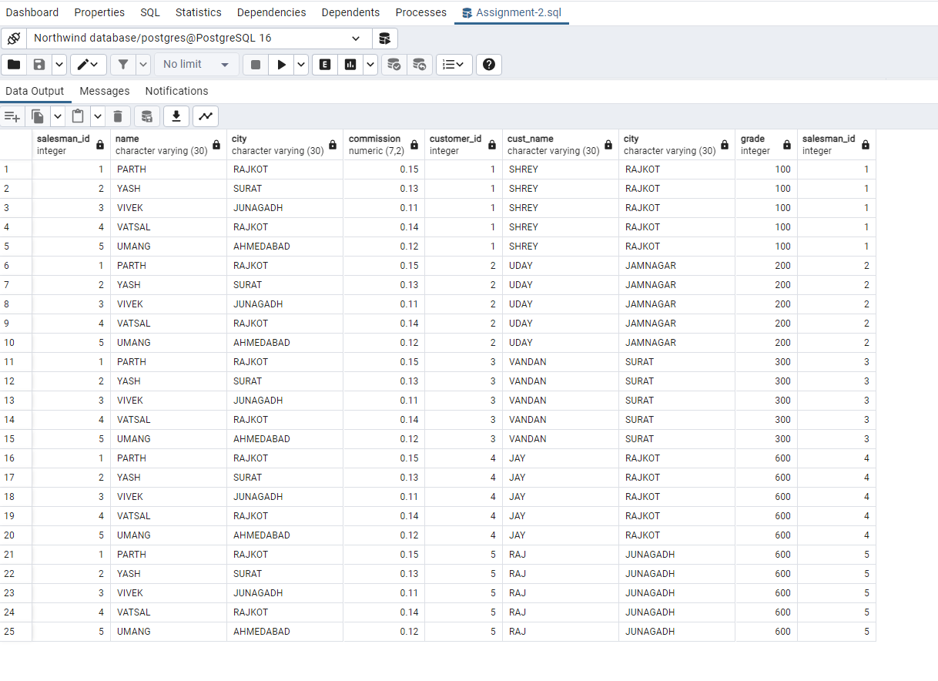
20. Write a SQL statement to make a Cartesian product between salesman and customer i.e. each salesman will appear for all customers and vice versa for those salesmen who must belong to a city which is not the same as his customer and the customers should have their own grade.
ANS:
SELECT * FROM SALESMAN CROSS JOIN CUSTOMER WHERE SALESMAN.city IS NOT NULL AND grade IS NOT NULL AND SALESMAN.city<>CUSTOMER.city;
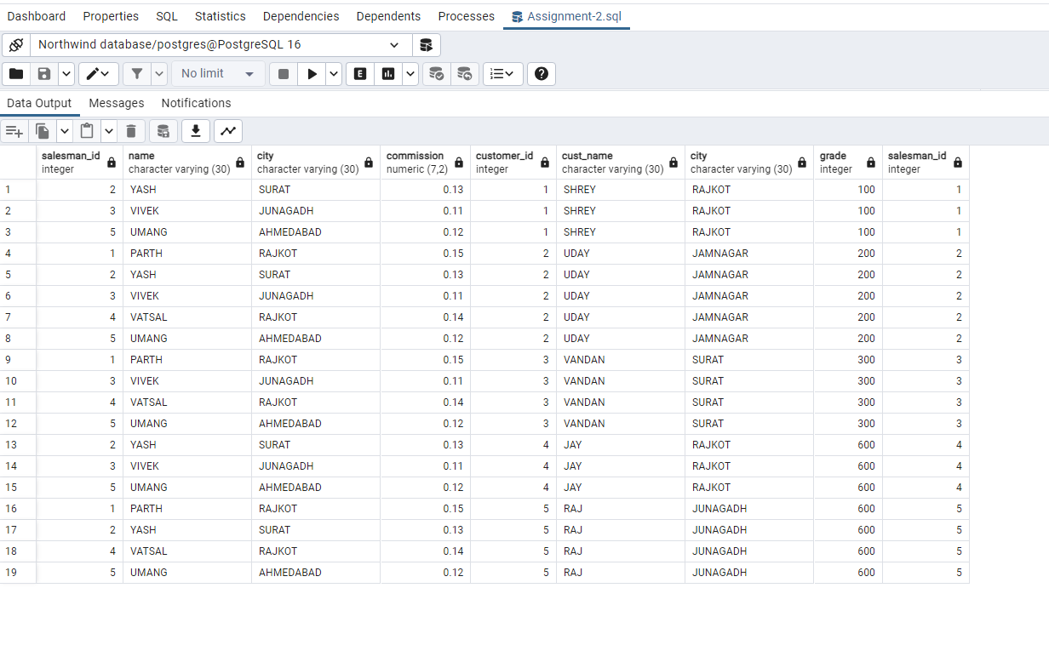

Assignment 3 : Retrieve data using Group By clause
Sample table1:
Department
-dept_id
-dept_name
Sample table2:
Employee
-emp_id
-dept_id
-mngr_id
-emp_name -salary

DEPARTMENT TABLE:
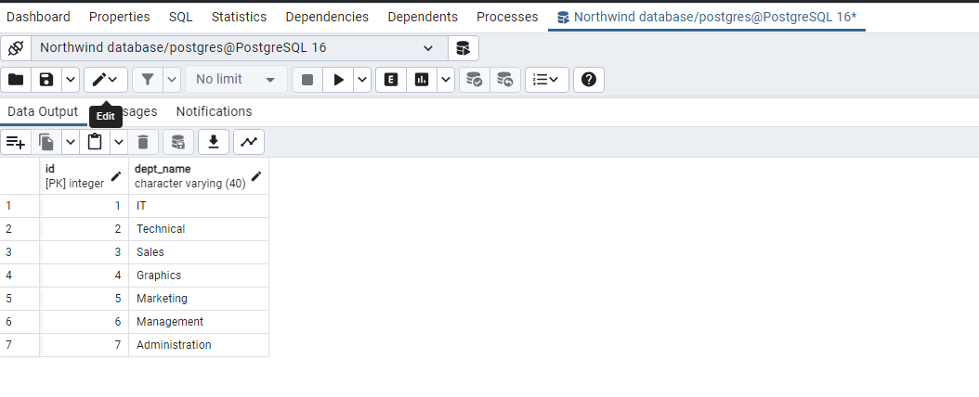

EMPLOYEE TABLE:

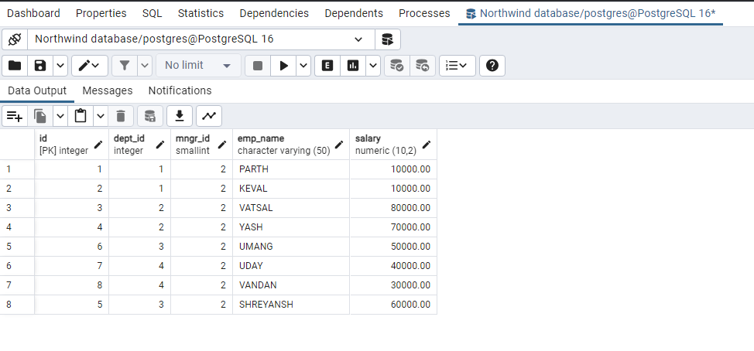

1. write a SQL query to find Employees who have the biggest salary in their Department.
ANS:
SELECT emp_name,dept_id FROM EMPLOYEE WHERE salary IN (SELECT MAX(salary) FROM EMPLOYEE GROUP BY dept_id);
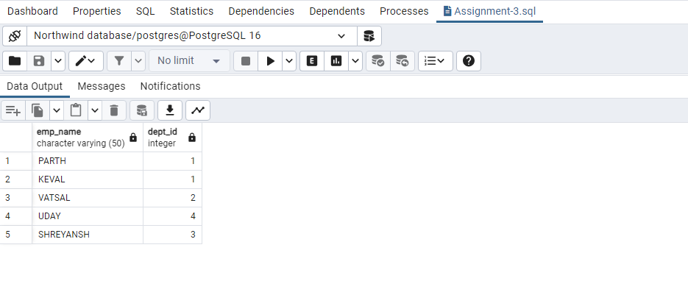
2. Write a SQL query to find Departments that have less than 3 people in it .
ANS:
SELECT id,dept_name FROM Department GROUP BY id HAVING COUNT(*)<3;
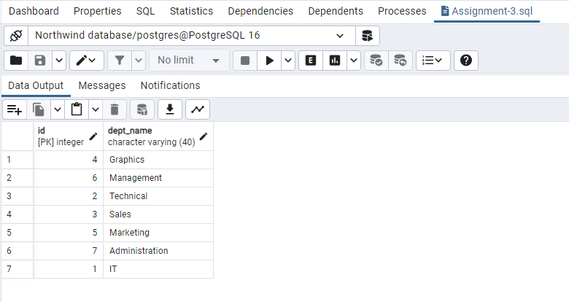
3. Write a SQL query to find All Department along with the number of people there.
ANS:
SELECT dept_id,COUNT(*) FROM Employee GROUP BY id;
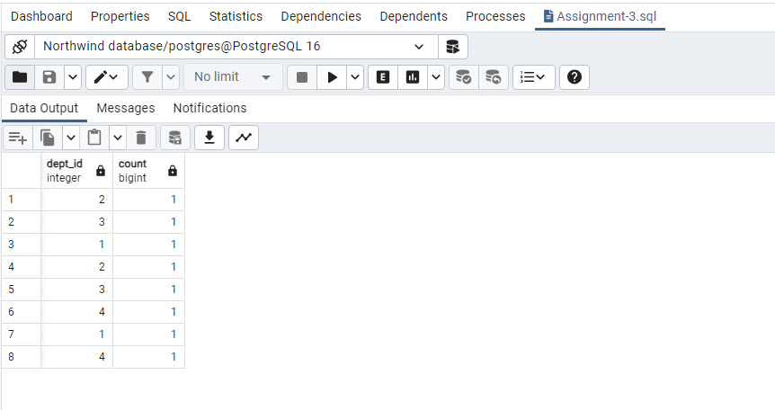
4. Write a SQL query to find All Department along with the total salary there.
ANS:
SELECT dept_id,SUM(salary)FROM Employee GROUP BY dept_id;
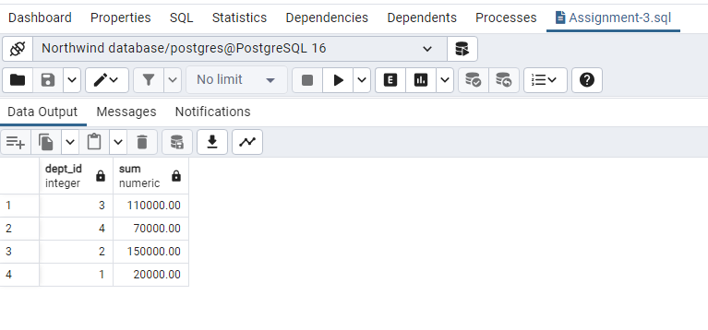

Assignment 4 : Create Stored procedure in Northwind database to insert or update a record in a table.

1. Create a stored procedure in the Northwind database that will calculate the average value of Freight for a specified customer.Then, a business rule will be added that will be triggered before every Update and Insert command in the Orders controller,and will use the stored procedure to verify that the Freight does not exceed the average freight. If it does, a message will be displayed and the command will be cancelled.
ANS:
CREATE OR REPLACE PROCEDURE insert_orders_with_check(order_id_input int,

customer_id_input,
character varying,
employee_id_input int,
order_date_input date,
required_date_input date,
shipped_date_input date,
ship_via_input int,
freight_input numeric,
ship_name_input character varying,
ship_address_input character varying,
ship_city_input character varying,
ship_region_input character varying,
ship_postal_code_input int,
ship_country_input character varying)
LANGUAGE plpgsql
AS $$
DECLARE
avg_freight real;
BEGIN
SELECT AVG(orders1.freight) INTO avg_freight
FROM orders1
WHERE orders1.customer_id = insert_orders_with_check.customer_id_input;
IF freight_input > avg_freight THEN
RAISE EXCEPTION 'Freight exceeds average freight for the customer.';
ELSE
INSERT INTO orders1 (order_id,
customer_id,
employee_id,
order_date,
required_date,
shipped_date,
ship_via,
freight,
ship_name,
ship_address,
ship_city,
ship_region,
ship_postal_code,
ship_country)
VALUES (order_id_input,
customer_id_input,
employee_id_input,
order_date_input,
required_date_input,
shipped_date_input,
ship_via_input,
freight_input,
ship_name_input,
ship_address_input,
ship_city_input,
ship_region_input,
ship_postal_code_input,
ship_country_input);
END IF;
END;
$$;
CALL insert_orders_with_check(
10247,
'VINET',
5,
CAST ('2024-01-25' AS DATE),
CAST ('2024-02-05' AS DATE),
CAST ('2024-02-05' AS DATE),
1,
500.00,
'Hanari Carnes',
'Rua do Paço, 67',
'Rio de Janeiro',
'RJ',
05454-876,
'Brazil'
);
select * from orders1;
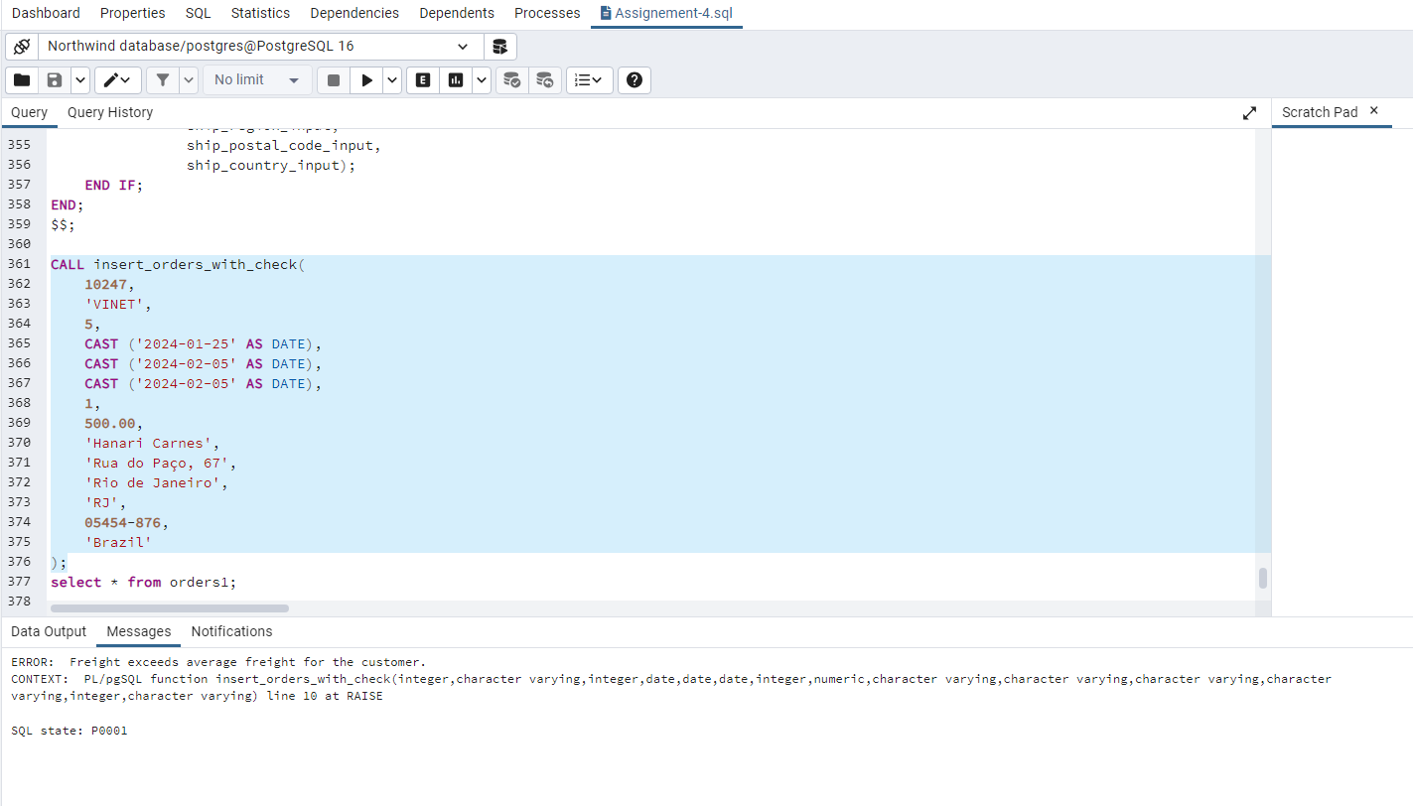

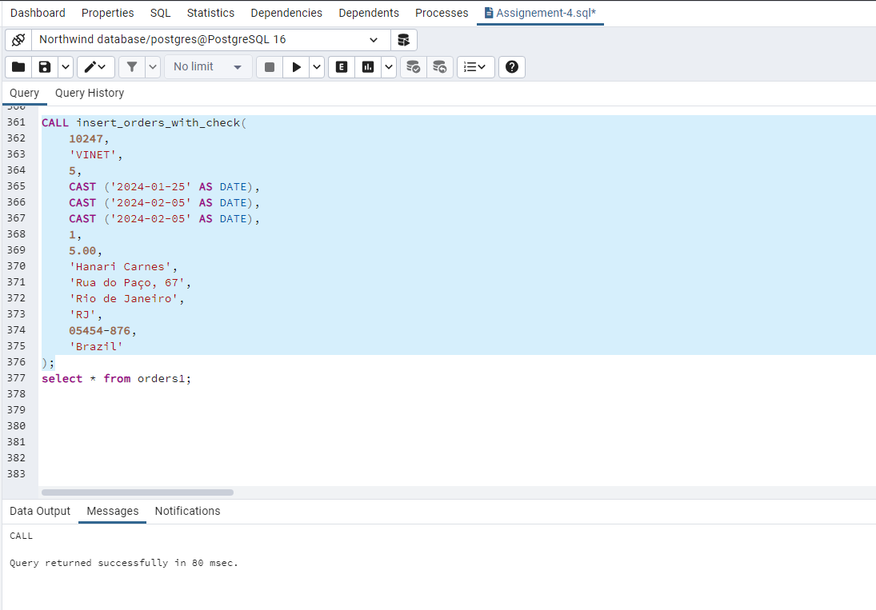

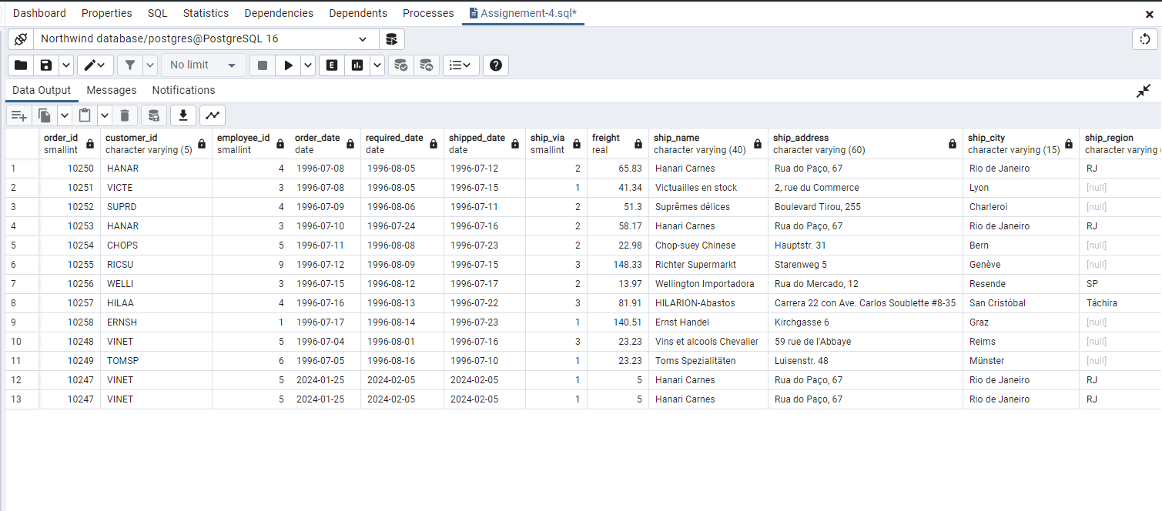

2. Write a SQL query to Create Stored procedure in the Northwind database to retrieve Employee Sales by Country.
ANS:
create or replace FUNCTION sales_by_country(cntry varchar)
returns table(
Country varchar,
last_name varchar,
first_name varchar,
shipped_date date,
order_id smallint
)
AS $$
begin
return query
SELECT
Employees1.Country,
Employees1.Last_Name,
Employees1.First_Name,
Orders1.Shipped_Date,
Orders1.Order_ID
FROM Employees1 INNER JOIN Orders1 ON Employees1.Employee_ID = Orders1.Employee_ID WHERE employees1.country=cntry;
end;
$$ LANGUAGE plpgsql;
select * from sales_by_country('USA');
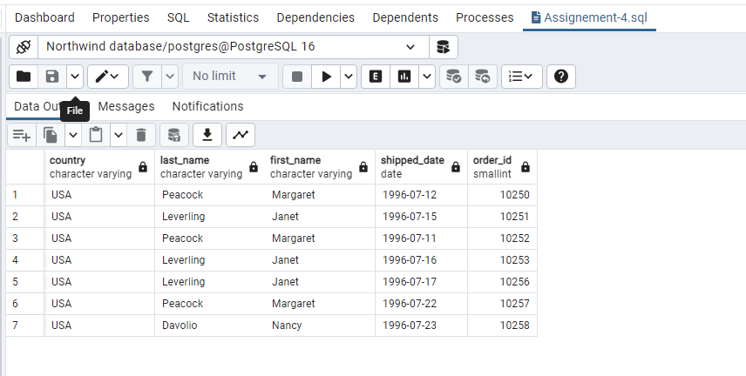

3. Write a SQL query to Create Stored procedure in the Northwind database to retrieve Sales by Year.
ANS:
create or replace FUNCTION sales_by_year(yr numeric)
returns table(
sale_year numeric,
ship_country varchar
)
AS $$
begin
return query
select extract(year from shipped_date) as sale_year, orders1.ship_country from
orders1 where extract(year from shipped_date) = yr order by sale_year;
end;
$$ LANGUAGE plpgsql;

select * from sales_by_year(1996);

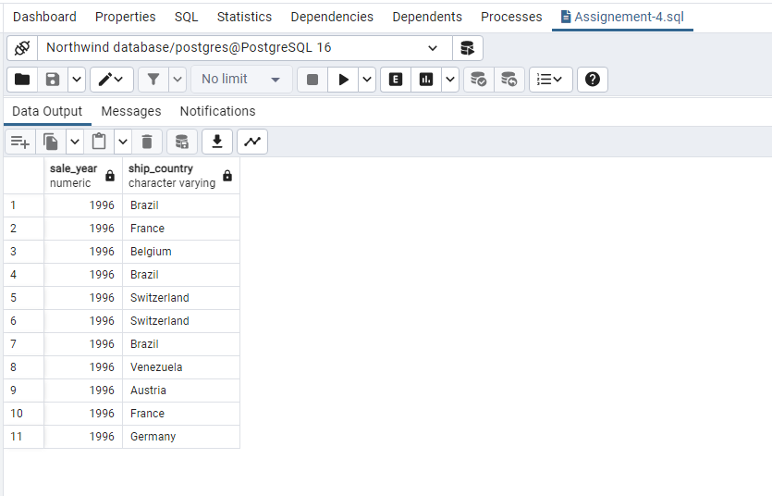
4. Write a SQL query to Create Stored procedure in the Northwind database to retrieve Sales By Category.
ANS:
create or replace function sales_by_category(ctgr varchar)
returns table(
category_name varchar,
description text
)
AS $$
begin
return query
select categories.category_name, categories.description from categorieswhere
categories.category_name =ctgr;
end;
$$ LANGUAGE plpgsql;
select * from sales_by_category('Beverages');

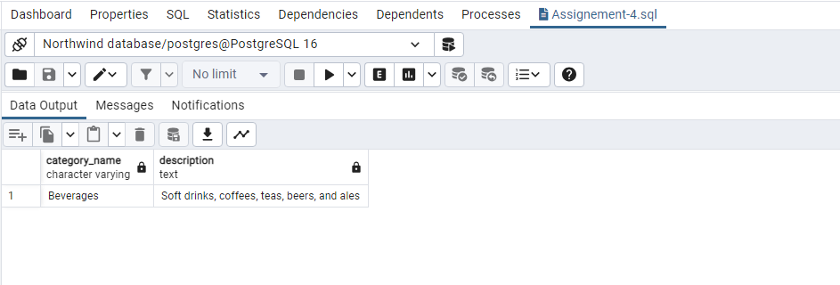
5. Write a SQL query to Create Stored procedure in the Northwind database to retrieve Ten Most Expensive Products.

ANS:
CREATE FUNCTION Top_Ten_Order2() RETURNS SETOF products1 as
$BODY$
BEGIN
RETURN QUERY SELECT *FROM products1 ORDER BY unit_price DESC LIMIT 10;
RETURN;
END;
$BODY$
LANGUAGE plpgsql;

select * from Top_Ten_Order2();

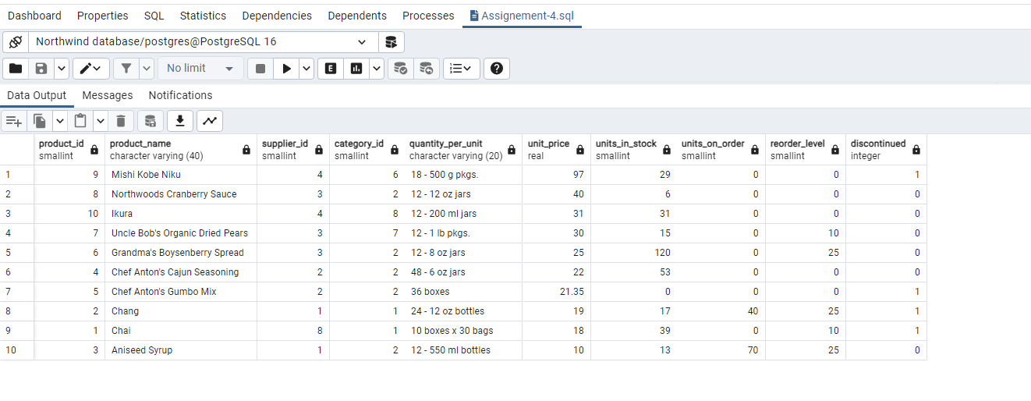
6. Write a SQL query to Create Stored procedure in the Northwind database to insert Customer Order Details.
ANS:
CREATE PROCEDURE insert_order_details(a smallint,b smallint,c real,d smallint,e real )
LANGUAGE SQL
AS $$
INSERT INTO order_details VALUES (a,b,c,d,e);
$$;

call insert_order_details(10::smallint, 12::smallint, 13::real, 14::smallint, 0.05::real)
select *from order_details;
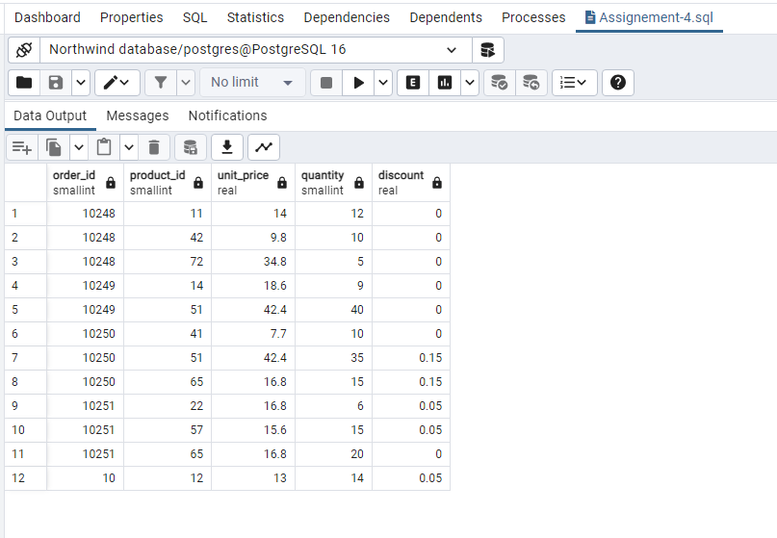
7. Write a SQL query to Create Stored procedure in the Northwind database to update Customer Order Details.
ANS:
create or replace procedure UpdateOrder(
a INT,
b decimal
)
language SQL
as $$
update orders1
set freight =b
where order_id = a;
$$

call UpdateOrder(10249,23.23)

